GSE VISITING TEAM, 16.04.2011-16.05.2011, PERSONAL INFO

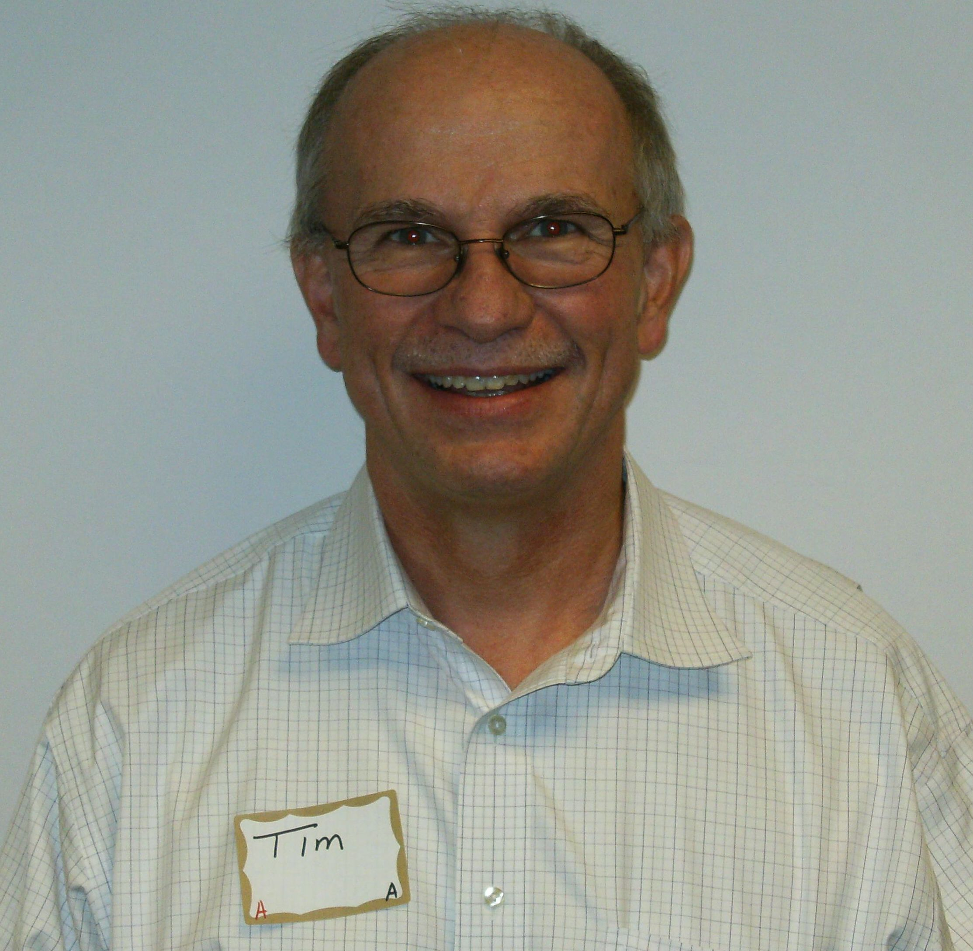 Team Leader Rotarian Timothy Gibson is 58 years old. He is married and has two children. He is from 28 years involved into Investment and Financial Services. His Rotary projects involvements are: Study Connection, Lunch Buddies, World Affairs Conference 8 years (5 years district chair), Club Board 9 years, R.Y.L.A. and Student Rotarians

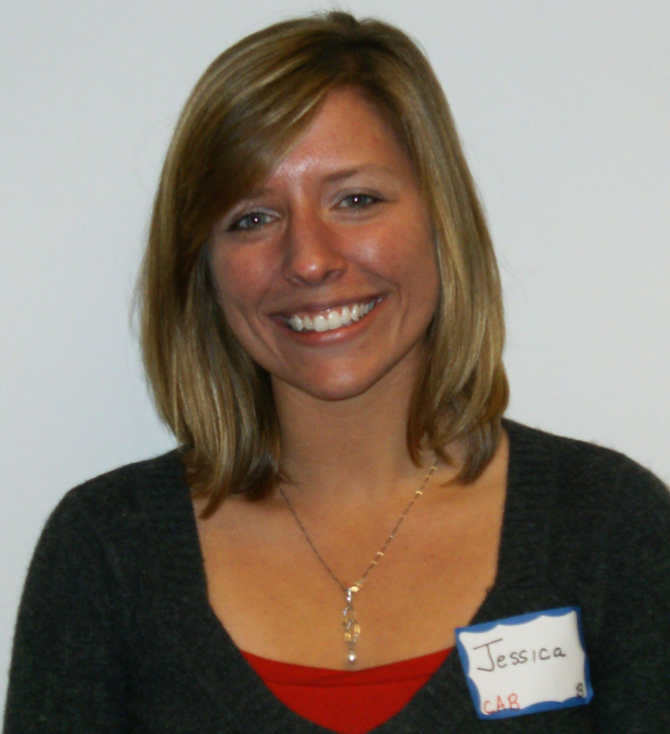 Team Member Jessica Rupchock is 27 years old and from 5 years works as a County Director and Social Worker in Human Services. She would like to discover new programming options that better meet the needs of the community. Observing social service business practices in Bulgaria would enhance her ability to recognize opportunities, as well as challenge her to pursue innovative methods outside the cultural and ideological norm that she knows.

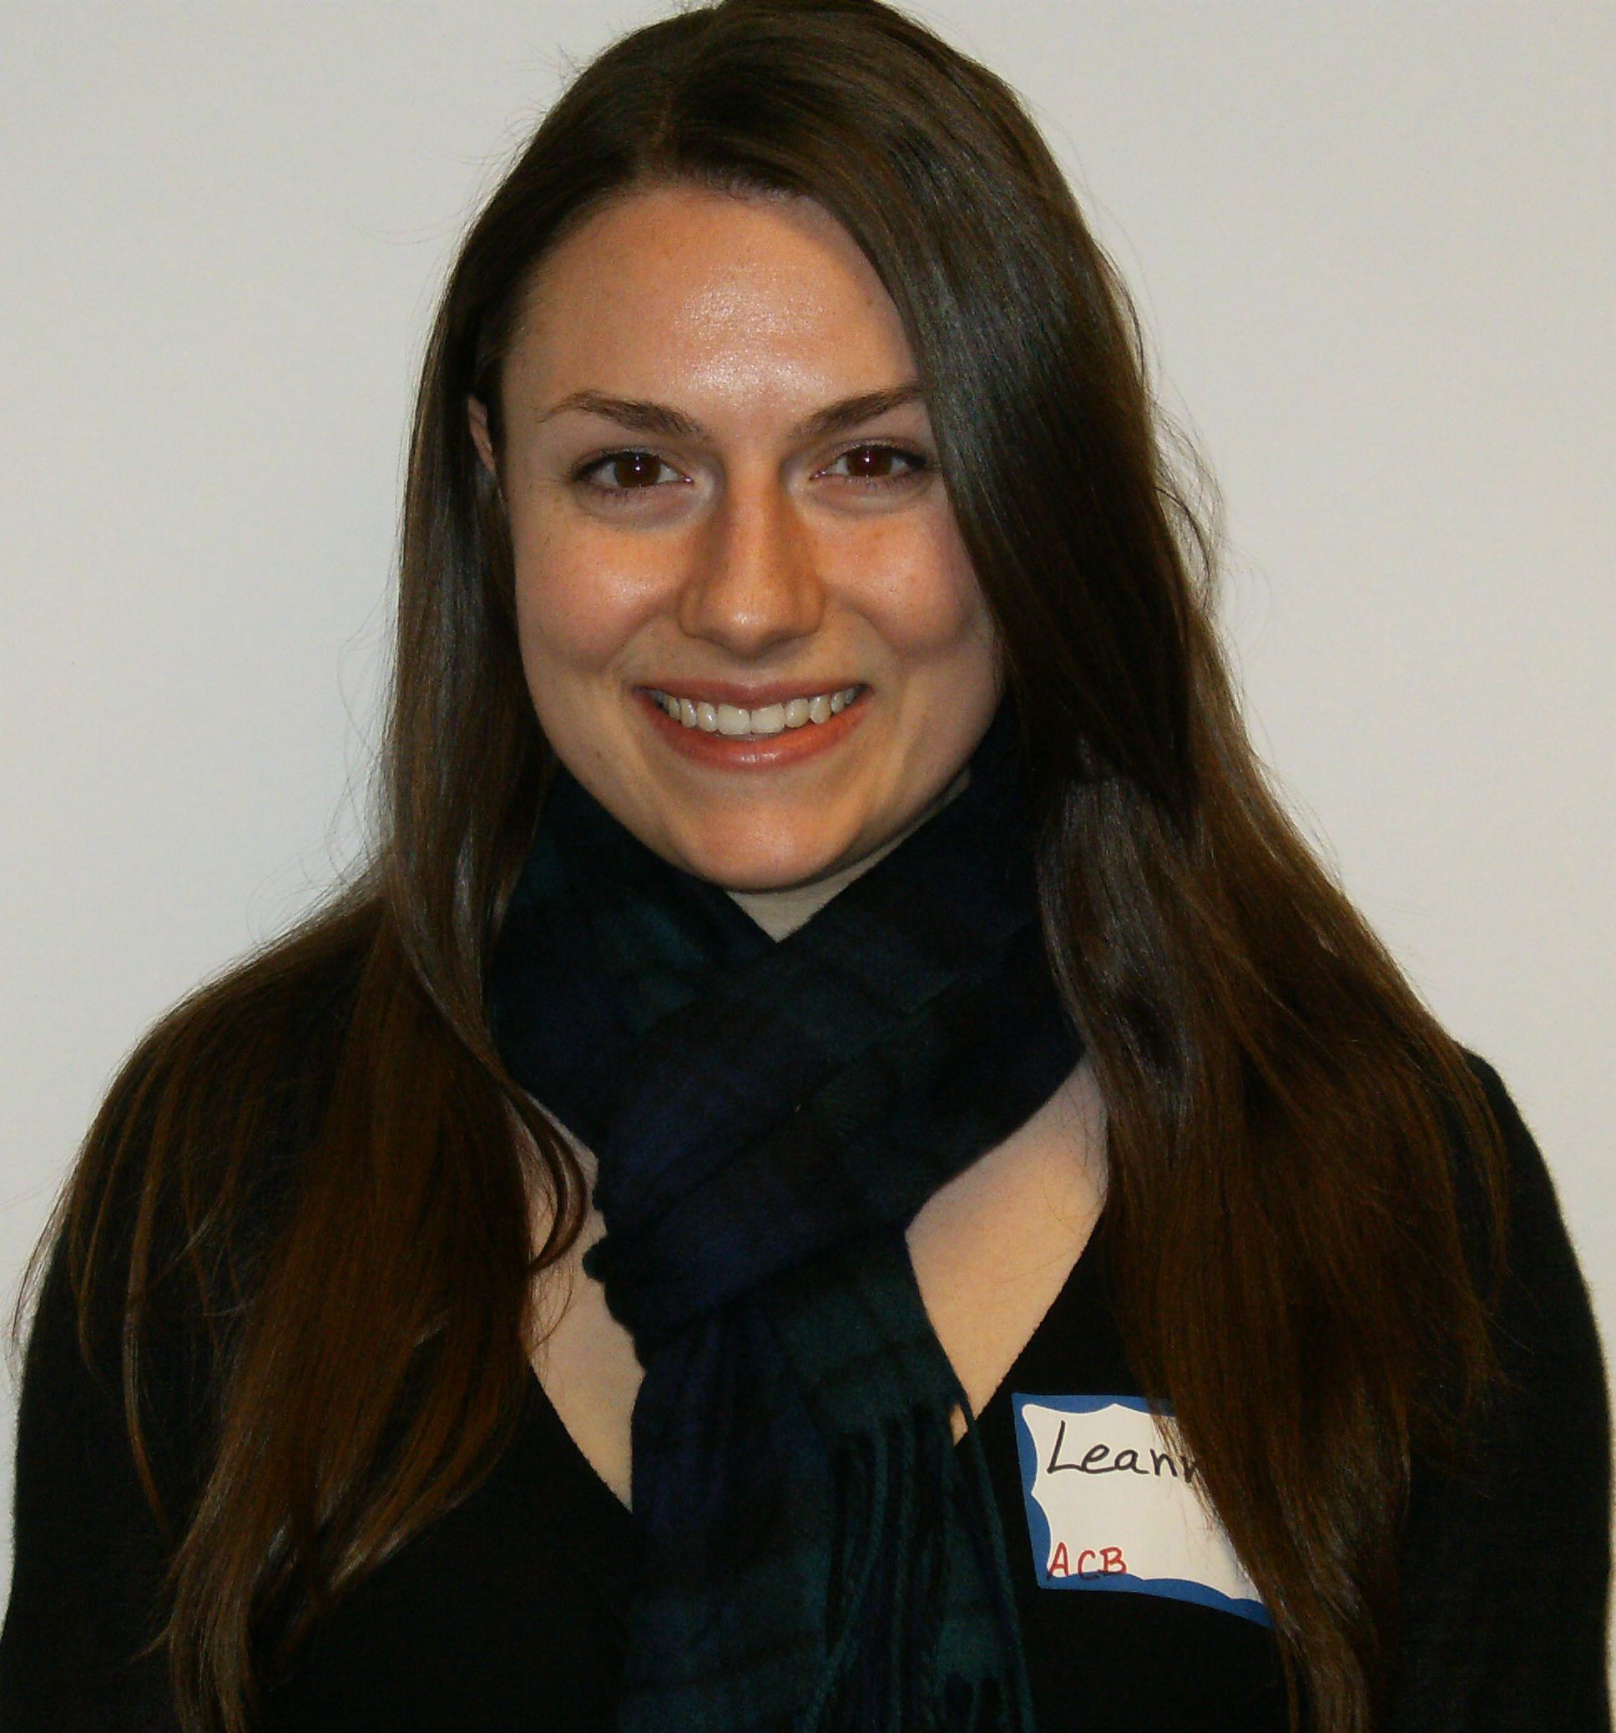 Team Member Leanna Harney is 26 years old and from one year she is an Education Coordinator and Museum Professional. Her interests are: Museums, Travel, Photography, Film, Fashion, Literature and Banking. The opportunity to learn about the history and culture of Bulgaria first hand would be invaluable personal experience. Being able to immerse her in a new land and its history and culture would help give her some insight into how other countries preserve and share their past with the public. She speaks some French.

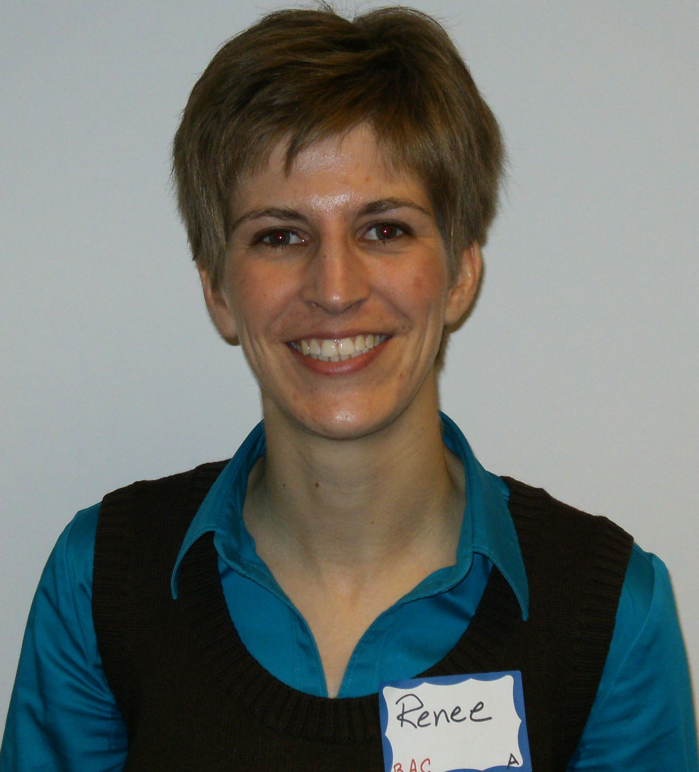 Team Member Renee Hochtetler is 30 years old and she is married. Two years ago, she started her own business as a content strategist-essentially planning, writing/editing, etc. She would like to learn about marketing techniques and practices in Bulgaria. She is very much interesting in storytelling too. She is fortunate to regularly meet ordinary people doing extraordinary things and to document their work-from researching social networks to leading middle school education trips. She speaks some Spanish.

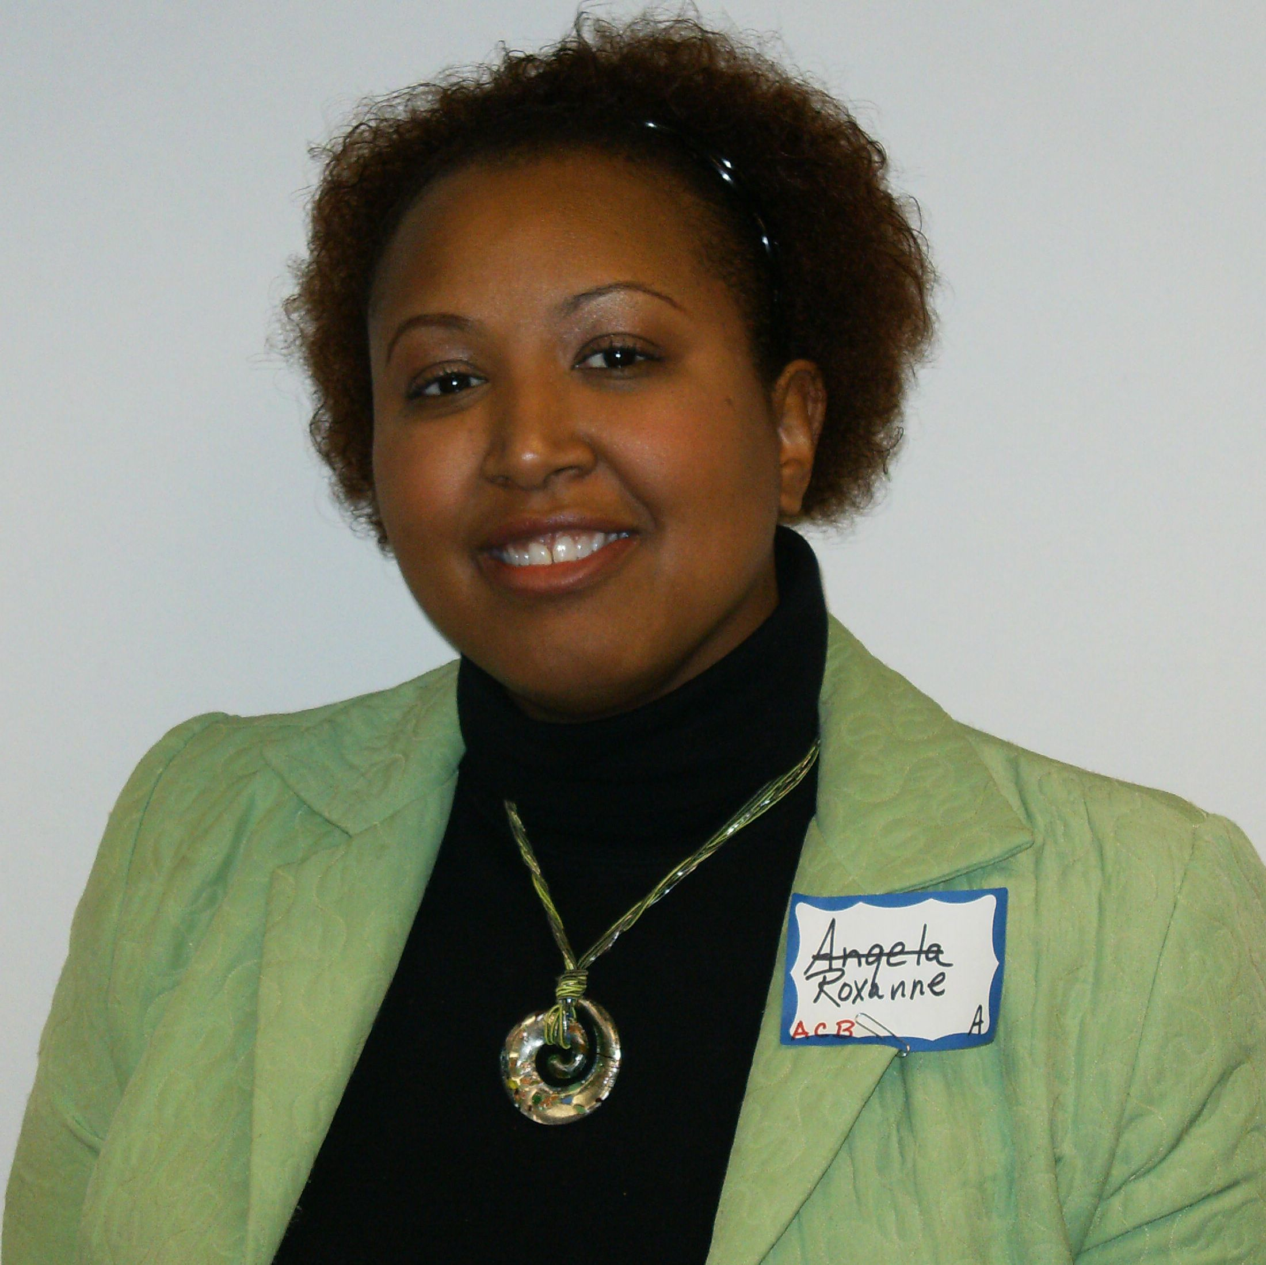 Team Member Roxanne Gregg is 39 years old and from seven years she is a Director of a College Preparatory Program for High School Students. Upward Bound is a high school support program that assists students with gaining college access and completion. This program is also supporting immigrants and refugees, along with native born students of all races, creating a multicultural educational experience.



